TASK 1 – REPORT
Student Performance Analysis

- 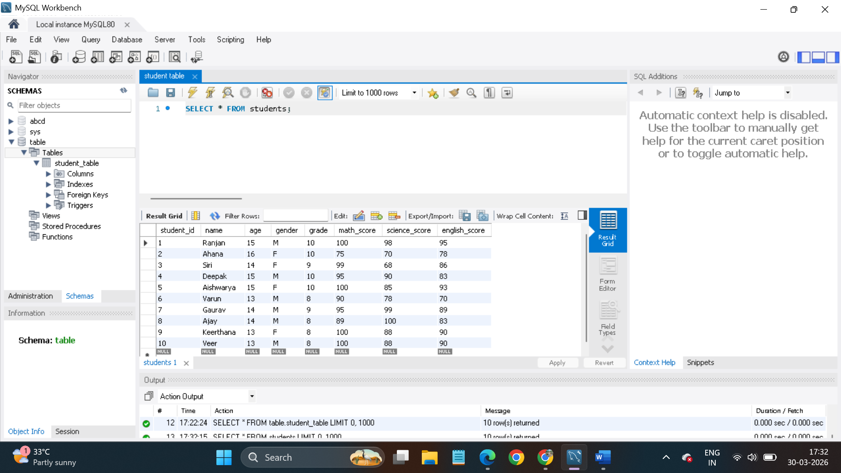
Table created

- 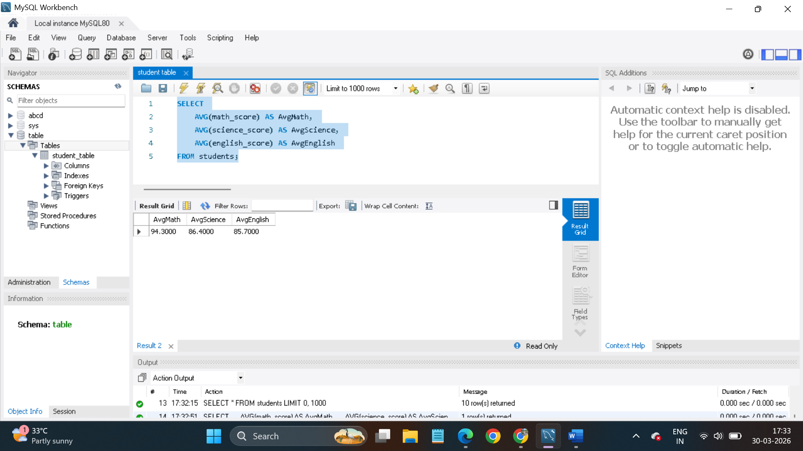
Overall Subject Averages: The class performed strongest in Mathematics with an average score of 95.3, followed by Science (86.4) and English (85.7).

- 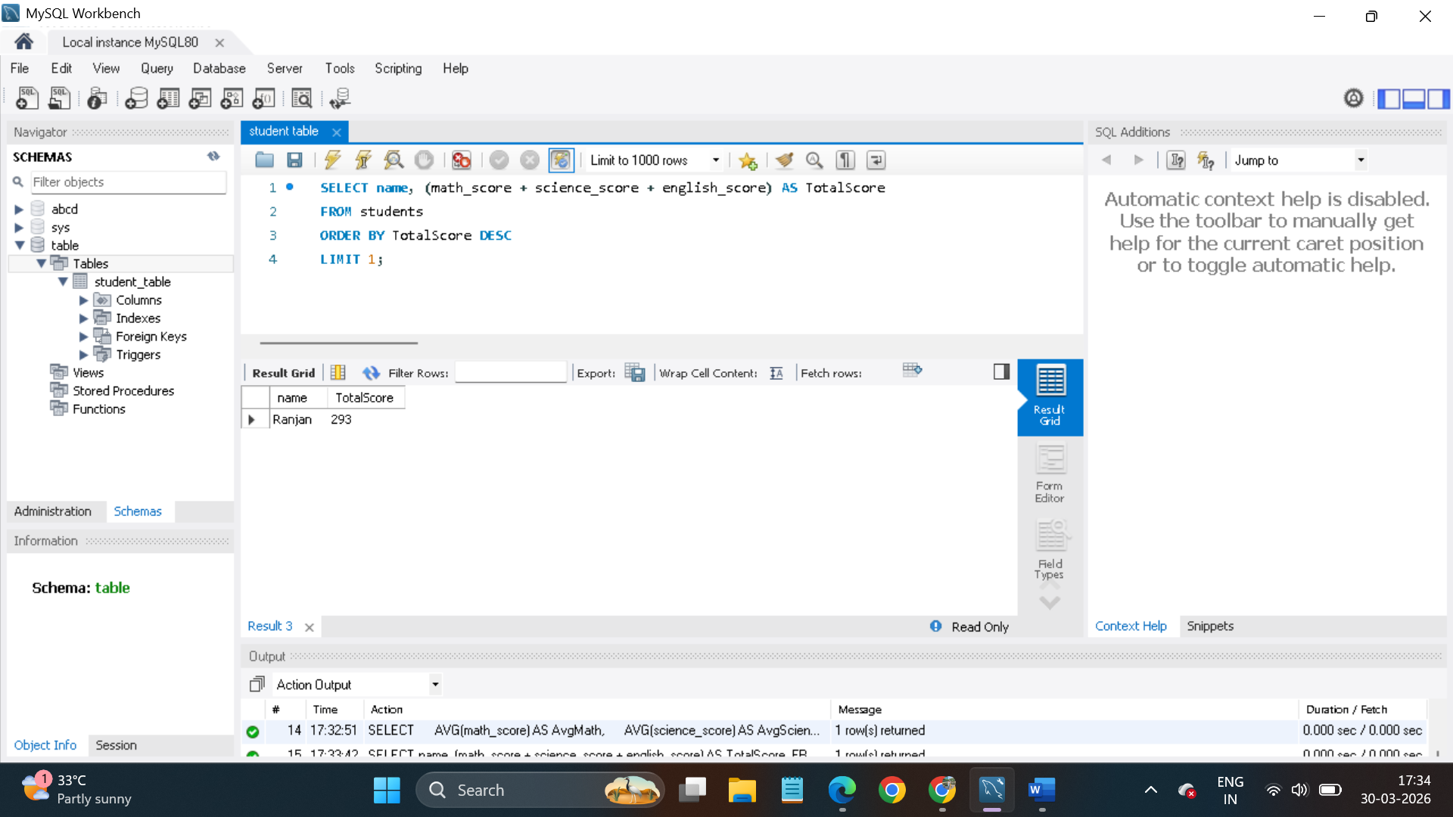
Top Performer: Ranjan is the top-performing student in the dataset, achieving a total combined score of 293 points.

- 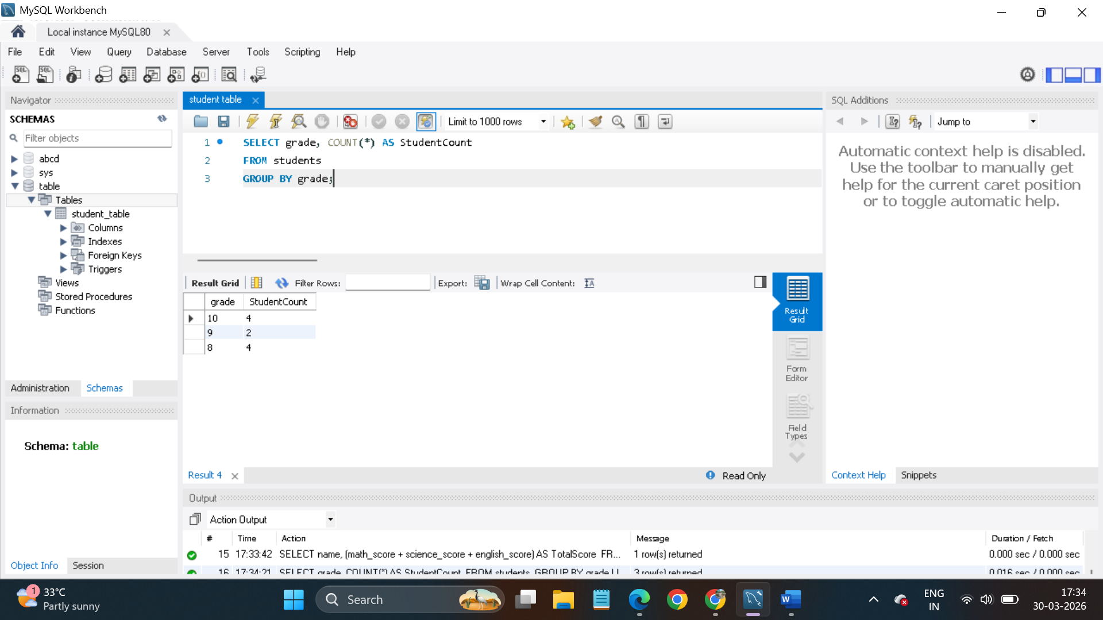
Grade Distribution: The student body is evenly split, with 4 students in Grade 10, 4 students in Grade 8, and 2 students in Grade 9.

- 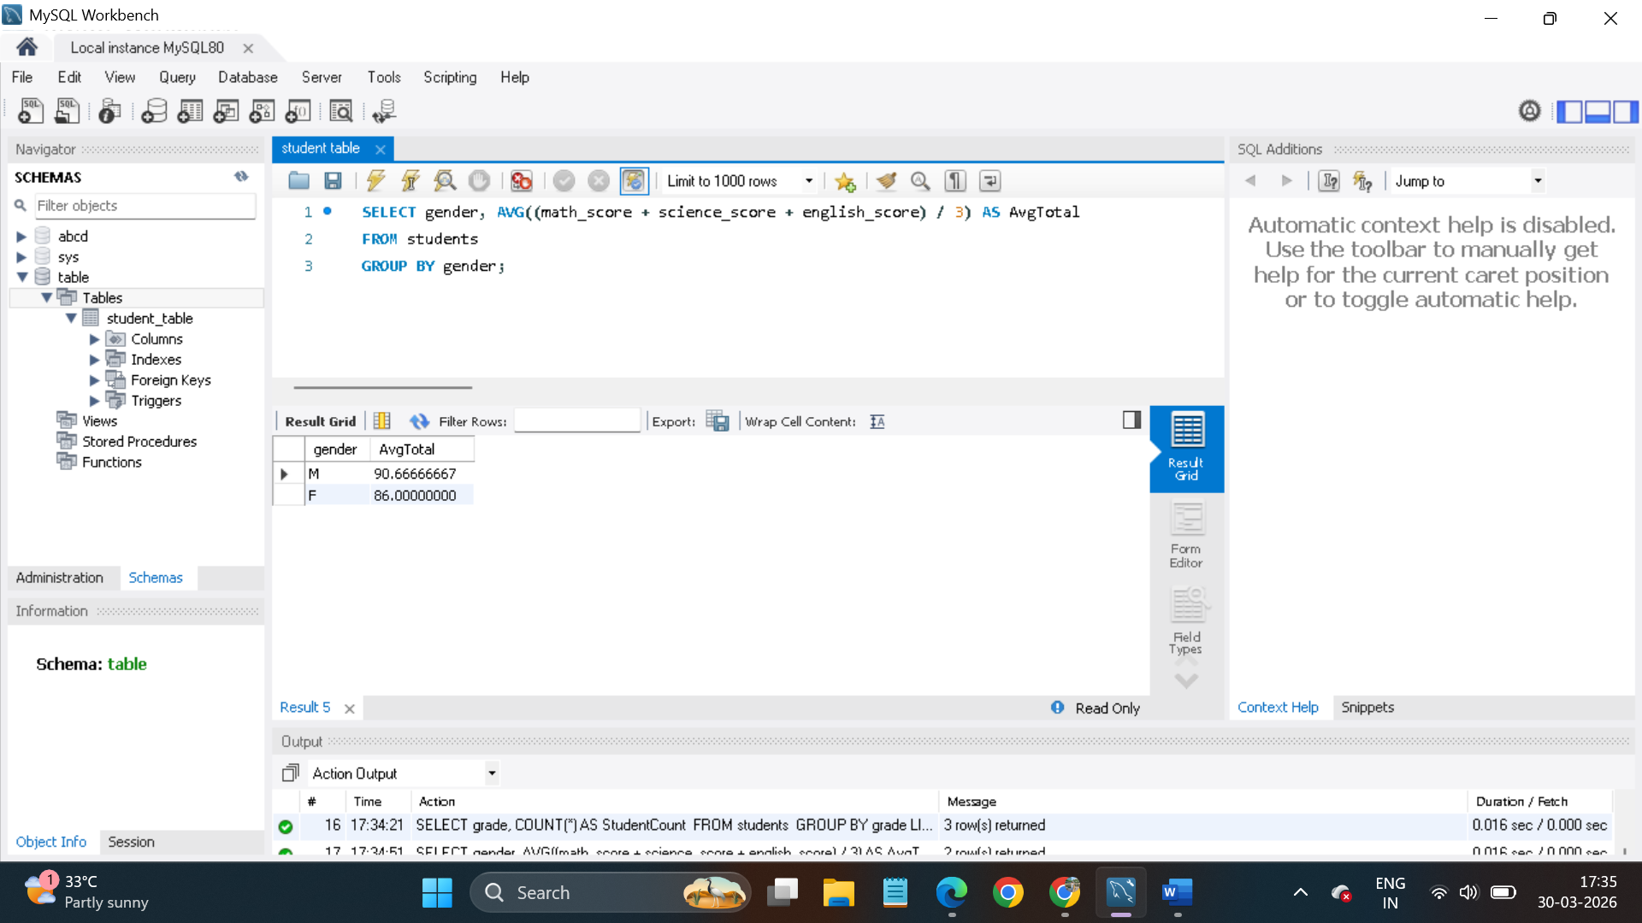
Gender Performance Insight: On average, male students scored slightly higher (90.6%) across all subjects compared to female students (86%).

- 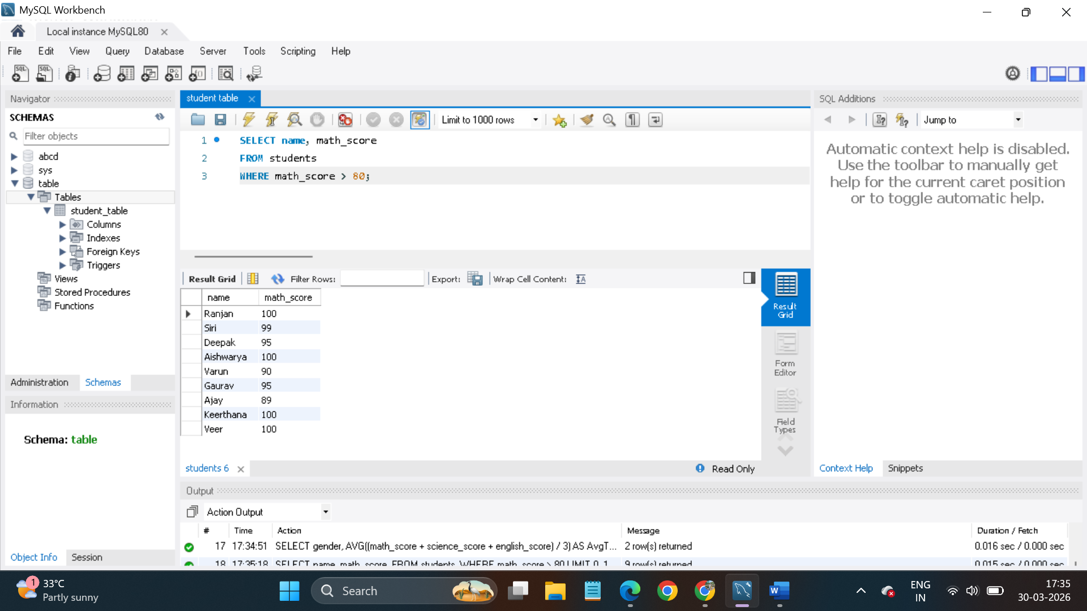
Math Excellence: 90% of the class (9 out of 10 students) are high achievers in Mathematics, scoring above 80.

Data Maintenance: Student records were successfully updated to reflect Ranjan's promotion to Grade 11.

